SafERteens Program

Receive Positive Patient Haiku Notification

Coordinate Intervention Delivery

Make Contact with Patient

Access SafERteens Intervention Tool and Conduct Intervention

Give Patient Resources (may be given electronically)

Chart New Note with Smart Phrase
- SAFERTEENSYES
- SAFERTEENSNO

Step #1: Receive Positive Patient Haiku Notification
When a patient screens positive, a notification to MCMU SafERteens group haiku will be sent with patient’s name and location in the ER. If patient is in waiting room, wait until patient is assigned a room placement before approaching.
To ensure you are receiving positive patient notifications via haiku messages, opt into MCMU SafERteens group haiku for every shift you are available to deliver SafERteens interventions or stay opted in at all times!
Step #2: Coordinate Intervention Delivery
If available to conduct the intervention, respond in the MCMU SafERteens group haiku letting other interventionists know you will approach the patient.
Chaplains: Work with sorting nurse (privately) to learn when patient is roomed.
Confirm with the social worker team positive patients are not awaiting a psychological evaluation.
Step #3: Make Contact with Patient
Approach the patient and pitch SafERteens.

“Hi, we are offering a free program to 14–20-year-olds called SafERteens. I would like to chat with you for a bit about your goals and review resources with you. This won’t interfere with your care today. Is this ok?” (If with a parent, include the parent in the conversation.)

Before intervention is conducted, ask family members or visitors to leave the room, if possible.
If contact is not made, skip to step 6.

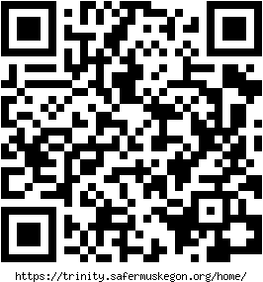
Step #4: Access SafERteens Intervention Tool and Conduct Intervention
- Go to https://trinity.safermuskegon.org/home/ or scan QR code.
- Select login and enter your site’s uber user.
  - Email address: ed
  - Password: qwertyop
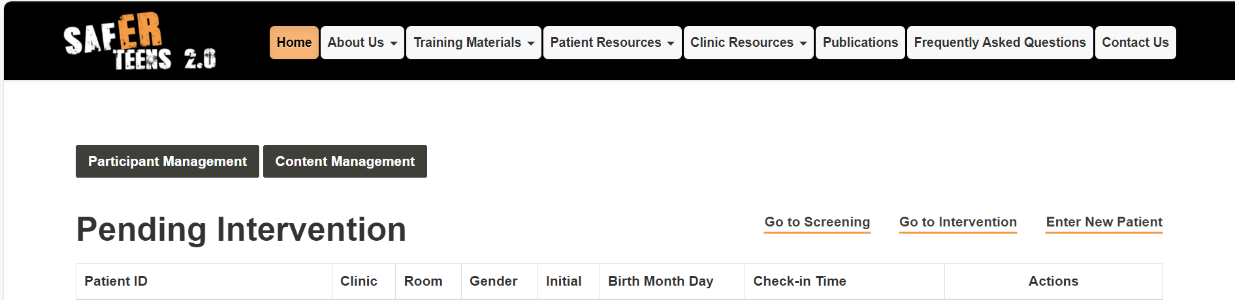
- Select Go to Intervention.

- Complete intervention.
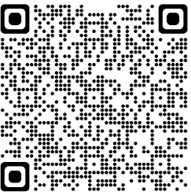
Step #5: Give Patient Resources
- When intervention concludes, provide patient with paper
or electronic copy of resources needed.
Step #6: Create New Chart Note with Smart Phrase
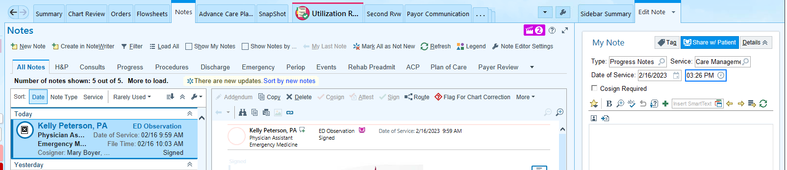
- In Notes, select New Note on the left.

- The note may be edited on the right-hand side.
- In the Type select Progress Notes.
- In Service, social workers should select CASE MANAGEMENT. See above.
- In Service, chaplains should select SPIRITUAL CARE. See below.
  - Chaplains should delete auto-populating Spiritual Care meeting draft text before continuing.
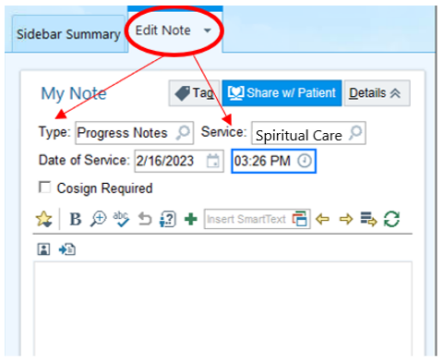

- To input smart phrase, select butler icon.
  - Select the wanted smart phrase, SAFERTEENSYES if the intervention was completed or partially completed.
  - Select SAFERTEENSNO if the intervention was not completed.

- Edit note with appropriate details. Place cursor before smart phrase, press F2 on keyboard, then select complete or not complete.
- If intervention was completed or partially completed:
  - Press F2 on keyboard and select date intervention took place.
  - Press F2 on keyboard and select the time the intervention was completed.
  - Press F2 on keyboard and select method of contact for intervention.
  - Press F2 on keyboard and select provided or not provided with resources depending on needs of patient.
  - Select accept, sign progress note, and choose current time. Ensure time is entered in 24-hour format.
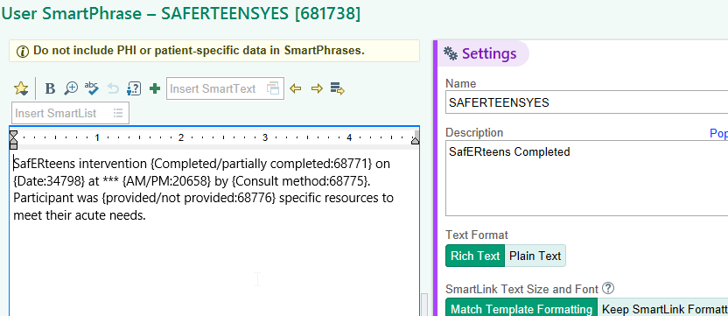

- If intervention was not completed:
  - Include that patient screened positive and was eligible for intervention.
  - Press F2 on keyboard and select the reason the intervention did not take place.
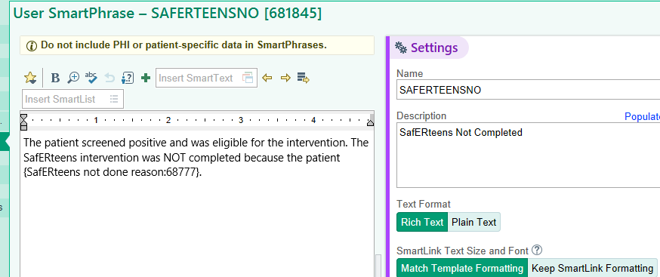
  - Select accept, sign progress note, and choose current time. Ensure time is entered in 24-hour format.

