SafERteens Program

Registration:

Identify age-eligible (14–20-year-old) patient

Access SafERteens screening tool

Hand patient iPad

Review, document, and communicate screening results

Give positive patients resource flyer

Sorter:
Document screening results in ED Triage note:
- SafERteens Pos (.STPOS)
- SafERteens Neg (.STNEG)
- Unable to Respond (.STU)
- Declined Screening (.STDEC)
For Positive Patients

Enter social work order

Send positive notification message to MCMU SafERteens haiku group

Step #1: Grab iPad for patients between the ages of 14 and 20.
- Say to patients/caregivers: we are asking patients 14-20 to answer 3 additional questions so that if time permits, they may be approached while they are here to receive additional community resources.

If patient is critical condition or declines the screening, go to step 4.

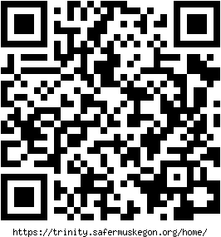
Step #2: Access SafERteens Screening Tool
- Go to https://trinity.safermuskegon.org/home/
- Select login and enter your site’s uber user.
  - Email address: ed Password: qwertyop
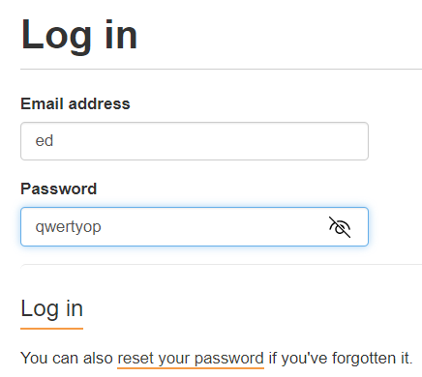
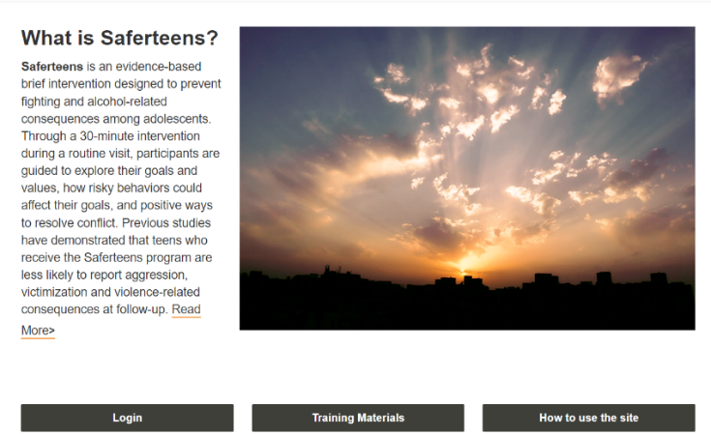

- Select Go to Screening.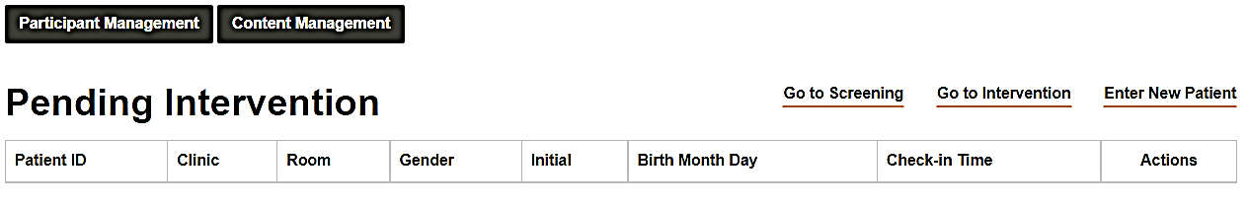

Step #3: Select Next and Hand Patient iPad
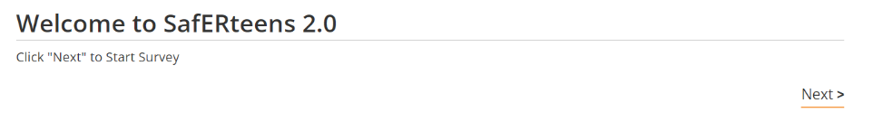

- The patient answers 3 questions privately.

Step #4: Review, Document,& Communicate Screening Results to Sorter.
- Patient will hand back the iPad.
Green check = Positive screen (left). Black minus = negative screen (right).
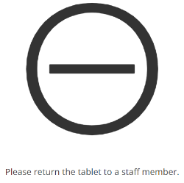
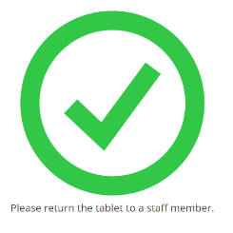
- On a sticky note, write down patient’s name and screening results. Give sticky note to sorter.
- If patient is too critical to complete screening record unable to respond.
- If patient or caregiver(s) refuses/declines screening record declined screening.
HELPFUL TIP: If no results to review, refer back to Pending Intervention dashboard.
- If patient was negative, there will be no new entry.
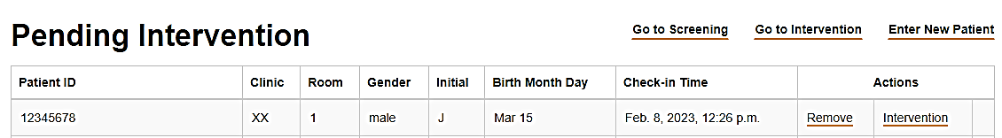
- If patient was positive, there will be a new entry under Check-in Time when the patient completed their screening.

Step #5: Give positive patients resource flyer.

Step #6: Sorter inputs screening results into patient’s ED triage note.
- Add ED Triage Note: SafERteens Neg (.STNEG), SafERteens Pos (.STPOS), Unable to Respond (.STU), or Declined (.STDEC).
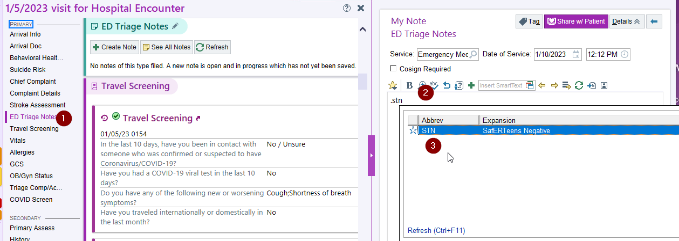

Step #7: For Positive Patients, Enter Social Work Order

- Navigate to Orders tab. Notice the additional Orders tab to the far right. Type Social Work in Search box. Click New or press Enter on your keyboard.
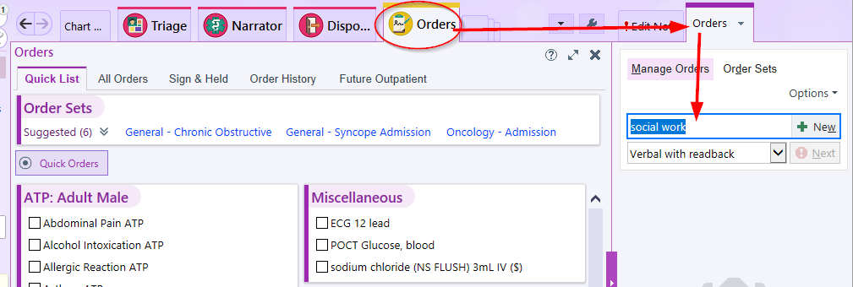

- When prompted select Consult to Social Work.
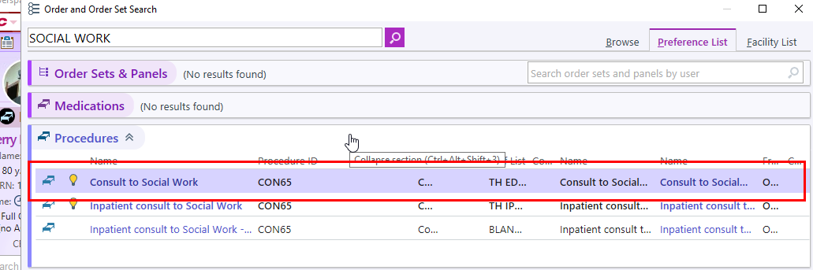

- Once the order launches, select Other for reason for consult. Specify
SafERTeens Positive for other reason.
  - Did you contact the consultant = Select Yes or No.
  - IF you select NO, you MUST input the reason as MSW Unavailable (MSWNA).
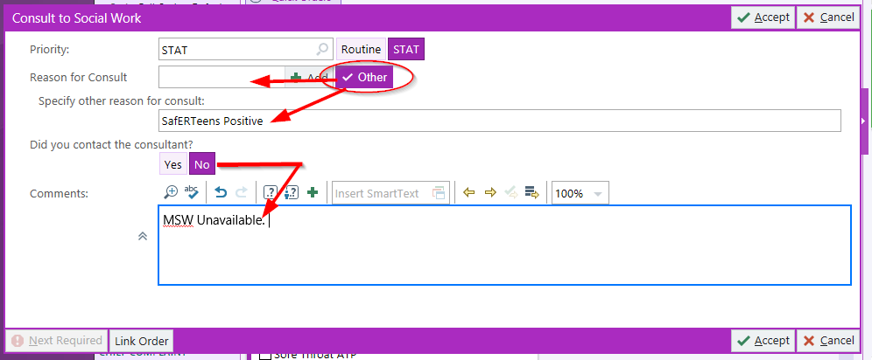

- Click Accept to finish order creation.
- When prompted, input Dr. Van Rees for ordering provider.

Step #7: Sorter sends positive patient notification to MCMU SafERteens haiku group.
- Find MCMU SafERteens haiku group and opt-in.
- Send positive patient notification to group. Include patient’s name and location in ED. If in waiting room, list waiting room.

